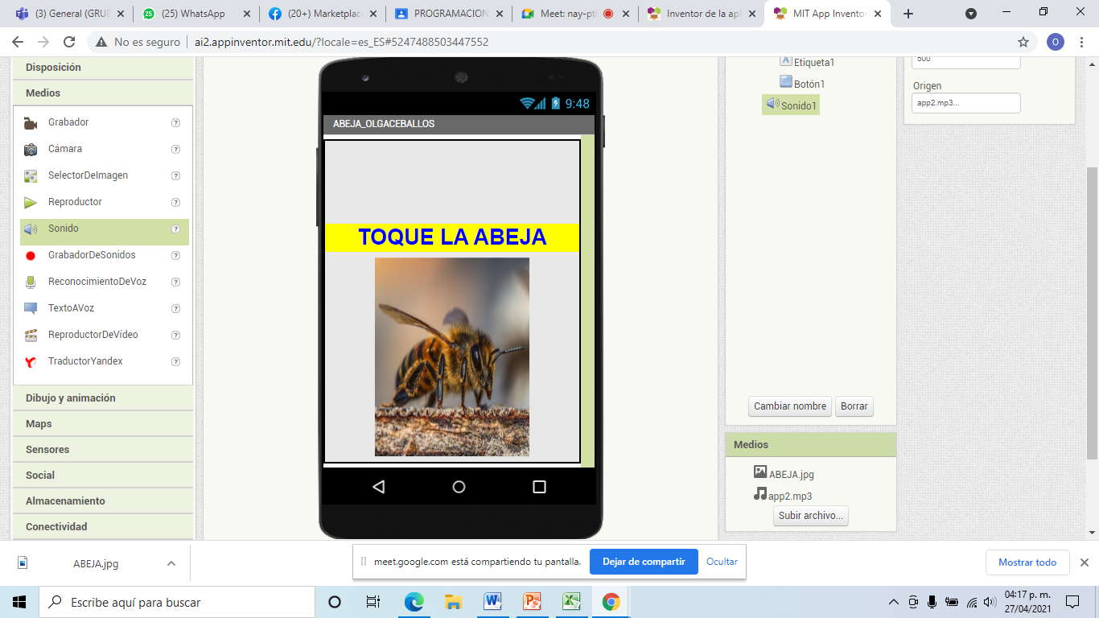
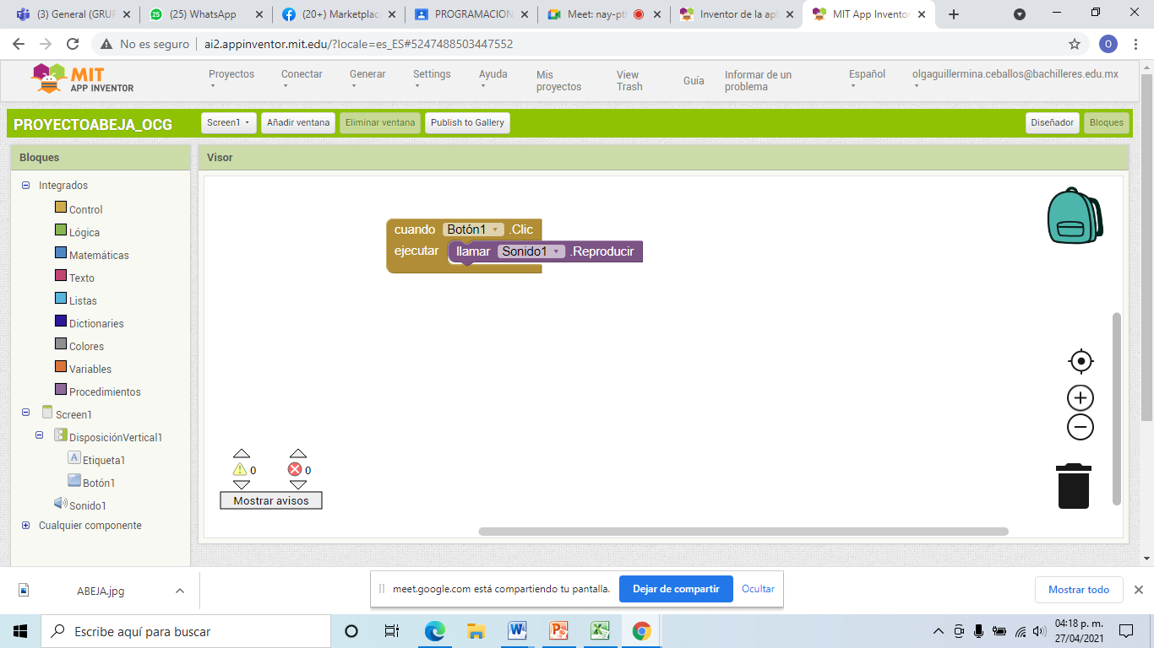
http://ai2.appinventor.mit.edu/?locale=es_ES#5247488503447552

